1.Open the Teaching Ratings data in SPSS and switch to variable view. Consider the following variables: age, gender, beauty, eval, tenure, students. Thought questions: Can you identify which variables are continuous variables and which ones are categorical variables? Are any of the variables in the above list of ordinal type?

ANS:-

Continous variables:age,beauty,eval,students

Categorical Variables:gender,tenure

2.Can you identify whether the Teaching Ratings data is a time series, cross-sectional, and/or multivariate data set?

ANS:-

It is a cross-sectional and multivariate data because it collected at one time and have many varaibles which helps in identifying relationship among the variables.

Not a time series it is not collected again and again

3.Does the Teaching Ratings data set represents information on an entire population or just a sample?
ANS:-
Sample

4.Using SPSS Statistics, find the mean, median, minimum, and maximum values for students and allstudents in the Teaching Ratings data.

ANS:-
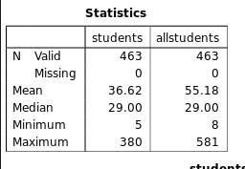

5.What is the mathematical relationship between variance and standard deviation?

Ans:-

varaince=(standarad deviation)^2

6.Using SPSS Statistics, try to reproduce the following descriptive statistics table on the Teaching Ratings data:
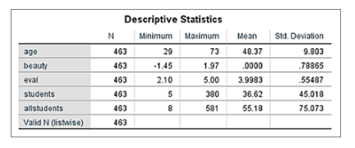

ANS:-
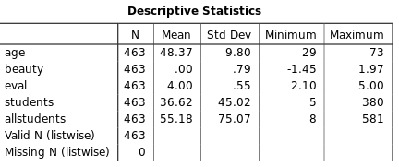

7.Create a histogram of beauty and briefly comment on the distribution of data (as a thought question).

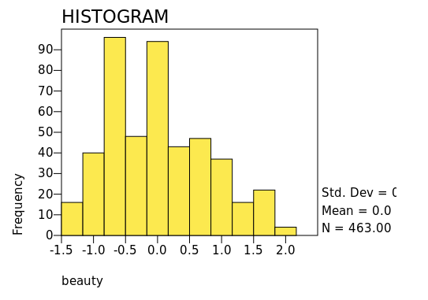

8.Does average beauty score differ by gender in the Teaching Ratings data? Produce averages and standard deviations for each of the two variables.

ANS:-

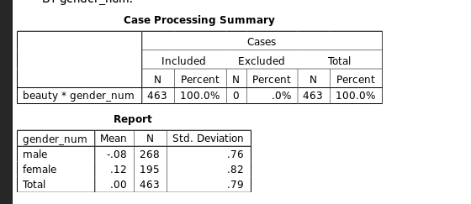

9.Does tenure status differ by vismin (visible minority) status? Produce cross tabulations explaining what percentage of visible minorities are tenured.

ANS:-

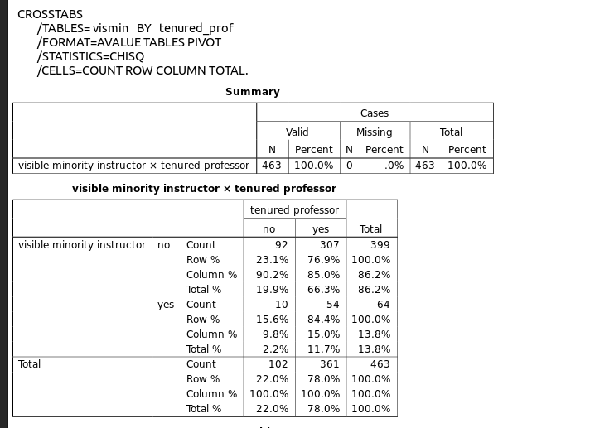
10.What is the probability of rolling two dice and getting 9 or less?
ANS:-6×6=36 total outcomes
Total favorable outcomes = 1 + 2 + 3 + 4 + 5 + 6 + 5 + 4 = 30
P(sum≤9)=30/36=5/6
5/6 ≈ 0.8333 or 83.33%

11.What is the probability of rolling two dice and getting 7 or less?

Ans:-
Total outcomes=6×6=36
Total favorable outcomes = 1 + 2 + 3 + 4 + 5 + 6 = 21
P(sum≤7)=21/36=7/12
7/12 ≈ 0.5833 or 58.33% is the probability of getting 7 or less.

12.With an average teaching evaluation score of 4 and standard deviation of 0.55, what is the probability of getting a teaching evaluation of greater than 4.75?

ANS:-
given
mean=4
standarad deviation=0.55
p(X>4.75)=(X-mean)/standarad deviation
=(4.75-4)/0.55
=1.36
p(Z>1.36)=1-0.9131
=0.0869
which is equal to 8.69% of probability of getting a teaching evaluation of greater than 4.75

